Date | 31 January 2026
Team ID | LTVIP2026TMIDS24384
Project Name | I Revolution_ A Data-driven Exploration of  Apple's iPhone Impact in India using tableau
Maximum Marks | 4 Marks

DATA FLOW DIAGRAM
A Data Flow Diagram (DFD) is a traditional visual representation of the information flows within a system. A neat and clear DFD can depict the right amount of the system requirement graphically. It shows how data enters and leaves the system, what changes the information, and where data is stored.

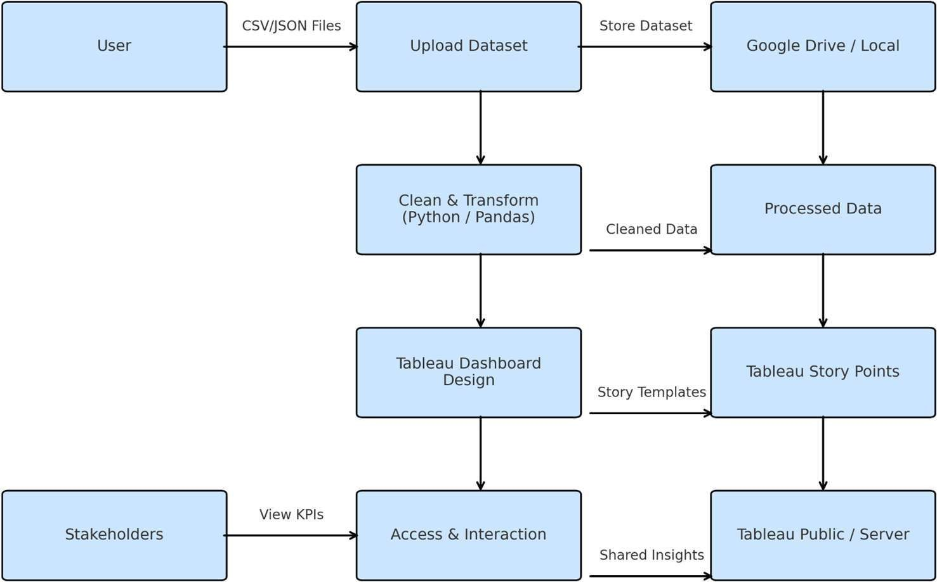

User stories:

Use the below template to list all the user stories for the product.

User Type | Functional Requirement (Epic) | User Story Number | User Story / Task | Acceptance Criteria | Priority | Release
Data Analyst | Data Collection | USN-1 | As a data analyst, I want to collect iPhone sales and market data in India so that I can analyze  market trends. | iPhone dataset is collected and loaded into Tableau | High | Sprint-1

User Type | Functional Requirement (Epic) | User Story Number | User Story / Task | Acceptance Criteria | Priority | Release
Data Analyst | Data Extraction | USN-2 | As a data analyst, I want to extract data from CSV/online  sources for analysis. | Data is successfully extracted without errors | High | Sprint-1
Data Analyst | Data Preparation | USN-3 | As a data analyst, I want to clean and preprocess iPhone sales data to remove missing and  inconsistent values. | Clean and structured dataset is available | High | Sprint-1
Data Analyst | Market Analysis | USN-4 | As a data analyst, I want to analyze iPhone market penetration across different years and regions in  India. | Regional and year-wise analysis charts are generated | Medium | Sprint-1
Business User | Data Visualization | USN-5 | As a business user, I want to view visual charts showing iPhone sales trends and growth. | Interactive visualizations are displayed correctly | High | Sprint-1
Business User | Dashboard | USN-6 | As a business user, I want a single dashboard to view all key iPhone market insights. | Dashboard displays all important KPIs and charts | High | Sprint-1
Stakeholder | Story | USN-7 | As a stakeholder, I want a Tableau story to understand insights step by step. | Story presents insights in a clear sequence | Medium | Sprint-2
Project Manager | Report | USN-8 | As a project | Report | High Sprint-2

User Type | Functional Requirement (Epic) | User Story Number | User Story / Task | Acceptance Criteria | Priority | Release
 |  |  | manager, I want a report summarizing the analysis and insights. | includes visuals and explanations
Administrator | Performance Testing | USN-9 | As an administrator, I want to test dashboard performance for smooth interaction. | Dashboard loads within acceptable time | Low Sprint-2
Administrator | Web Integration | USN-10 | As an administrator, I want to integrate the Tableau dashboard into a web application. | Dashboard is accessible through a web browser | Medium Sprint-2
End User | Online Access | USN-11 | As an end user, I want to access the iPhone analysis dashboard online without  installing Tableau. | Dashboard opens successfully via web link | Medium Sprint-2

